LAB ACTIVITY 3 – PART 3: THE DATA FOUNDATION
Topic: 3.1.3 Functions & Event Handling
Learning Outcomes
By the end of this lab, students will be able to:
- Define and use JavaScript functions.
- Differentiate between function declaration and function expression.
- Apply parameters and return values in functions.
- Use event handling to make web pages interactive (onclick, onchange, onmouseover, etc.).

Part A: Theory (20 minutes)
- Function in JavaScript
  - A reusable block of code designed to perform a specific task.
  - Can take input (parameters) and produce output (return values).
- Function Declaration vs Function Expression
  - Declaration:
function greet() {
alert("Hello!");
}
Expression:
let greet = function() {
alert("Hello!");
};
- Event Handling
  - Events are actions performed by the user (e.g., clicking a button, hovering, typing).
  - Events can trigger functions.
  - Common event attributes:
    - onclick → when user clicks an element
    - onmouseover → when user hovers over element
    - onchange → when input value changes
    - onkeyup / onkeydown → when typing in a field

Part B: Guided Activity (Step by Step)
Task 1: Simple Function
- Create a button labeled “Say Hello”.
- Write a function sayHello() that shows an alert "Hello, welcome to JavaScript Lab!".
- Connect the button’s onclick event to the function.

Task 2: Function with Parameters
- Add an input box where the user types their name.
- Create a function greetUser(name) that displays "Hello, [name]!".
- Link it to a button that, when clicked, calls the function with the input value.

Task 3: Function with Return Value
- Create a function square(num) that returns the square of a number.
- Add an input field and a button.
- When the button is clicked, show the result in a <p> element.

Task 4: Event Handling Examples
- onmouseover & onmouseout: Change the background color of a box when the mouse hovers over it and reset when the mouse leaves.
- onchange: Create a dropdown with colors (Red, Blue, Green). When the user selects one, change the page’s background color.
- onkeyup: Create a text input that shows the current typed text live below it.

Part 1: The "Professional Skeleton" (HTML & CSS)
Instruction:
Create a new file named lab3_1_3.html. Copy and paste the code below. This code utilizes CSS Flexbox for layout and CSS Transitions for smooth visual feedback, providing a standard UI/UX experience for your web application.
HTML
<!DOCTYPE html>
<html lang="en">
<head>
<meta charset="UTF-8">
<meta name="viewport" content="width=device-width, initial-scale=1.0">
<title>Lab 3.1.3 - Functions & Events</title>
<style>
body {
font-family: 'Segoe UI', Tahoma, Geneva, Verdana, sans-serif;
margin: 0;
padding: 0;
transition: background 0.3s ease;
line-height: 1.6;
background-color: #f4f7f6;
}
nav {
background: #333;
padding: 15px;
position: sticky;
top: 0;
z-index: 1000;
text-align: center;
box-shadow: 0 2px 5px rgba(0,0,0,0.1);
}
nav a {
color: white;
margin: 0 15px;
text-decoration: none;
font-weight: bold;
font-size: 0.9rem;
}
nav a:hover { color: #3498db; }
section {
padding: 40px 20px;
border-bottom: 1px solid #ddd;
max-width: 800px;
margin: 20px auto;
background: white;
border-radius: 8px;
}
h2 { color: #2c3e50; border-left: 5px solid #3498db; padding-left: 15px; margin-bottom: 20px; }
.box {
width: 150px;
height: 150px;
background: #ecf0f1;
display: flex;
align-items: center;
justify-content: center;
margin: 15px 0;
border: 2px dashed #95a5a6;
border-radius: 8px;
transition: all 0.3s ease;
font-weight: bold;
}
.output {
margin-top: 15px;
padding: 12px;
background: #f8f9fa;
border-radius: 4px;
font-weight: bold;
color: #2c3e50;
min-height: 20px;
border: 1px solid #eee;
}
input, select, button { padding: 10px; margin: 5px 0; border-radius: 4px; border: 1px solid #ccc; font-size: 14px; outline: none; }
button {
background: #3498db;
color: white;
border: none;
cursor: pointer;
transition: background 0.2s;
font-weight: 600;
}
button:hover { background: #2980b9; }
img {
display: block;
margin-top: 10px;
border-radius: 8px;
box-shadow: 0 4px 12px rgba(0,0,0,0.1);
background: #eee;
transition: transform 0.3s;
}
img:hover { transform: scale(1.02); }
</style>
</head>
<body>

<nav>
<a href="#task1">Task 1</a> <a href="#task2">Task 2</a> <a href="#task3">Task 3</a>
<a href="#task4">Task 4</a> <a href="#exercises">Exercises</a>
</nav>

<section id="task1">
<h2>Task 1: Simple Function</h2>
<p>Trigger a basic JavaScript alert using the <code>onclick</code> event.</p>
<button onclick="sayHello()">Say Hello</button>
</section>

<section id="task2">
<h2>Task 2: Parameters</h2>
<p>Pass data from an input field into a function.</p>
<input type="text" id="username" placeholder="Enter your name">
<button onclick="greetUser()">Greet Me</button>
<p id="greetOutput" class="output"></p>
</section>

<section id="task3">
<h2>Task 3: Return Value</h2>
<p>Calculate the square of a number using a logic function that returns a value.</p>
<input type="number" id="squareInput" placeholder="Enter a number">
<button onclick="calculateSquare()">Get Square</button>
<p id="squareOutput" class="output"></p>
</section>

<section id="task4">
<h2>Task 4: Event Handling</h2>
<h3>Mouse Over/Out</h3>
<div class="box" id="hoverBox" onmouseover="hoverColor()" onmouseout="resetColor()">Hover Me</div>

<h3>Change Event</h3>
<select id="colorSelect" onchange="changeBackground()">
<option value="white">-- Choose Theme --</option>
<option value="#ff7675">Soft Red</option>
<option value="#74b9ff">Sky Blue</option>
<option value="#55efc4">Mint Green</option>
</select>

<h3>Keyboard Event</h3>
<input type="text" id="liveInput" placeholder="Type live..." onkeyup="showLiveText()">
<p id="liveOutput" class="output"></p>
</section>

<section id="exercises">
<h2>Lab Exercises</h2>
<h3>Q1. Reusable Calculator</h3>
<input type="number" id="num1" placeholder="Num 1">
<input type="number" id="num2" placeholder="Num 2">
<button onclick="calculateAll()">Calculate All</button>
<div id="calcOutput" class="output"></div>

<h3>Q2. Voting Eligibility</h3>
<input type="number" id="ageInput" placeholder="Enter your age">
<button onclick="checkEligibility()">Check Status</button>
<p id="eligibilityOutput" class="output"></p>

<h3>Q3. DOM Manipulation</h3>
<p id="textChange">Status: Before Click</p>
<button onclick="changeText()">Update Text</button>

<h3>Q4. Image Interaction</h3>
<img src="https://via.placeholder.com/200/3498db/FFFFFF?text=Image+1" id="hoverImage" width="200" onmouseover="changeImage()" onmouseout="resetImage()">

<h3>Q5. Multiplier Table</h3>
<input type="number" id="tableInput" placeholder="Enter multiplier">
<button onclick="generateTable()">Generate</button>
<div id="tableOutput" class="output"></div>
</section>

<script>
// JAVASCRIPT LOGIC WILL BE ADDED HERE
</script>

</body>
</html>

Part 2: Coding the Logic (Step-by-Step)
Add the following JavaScript code inside your <script> tags one task at a time.
Task 1: Simple Function
Objective: To understand how to trigger a block of code via a user event.
- Requirement: Create a basic interaction that triggers a browser alert.
- Implementation: Define a function named sayHello() that uses the alert() method.
- Code:

// Task 1: Basic Alert
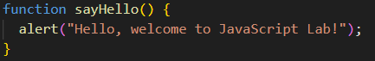
Task 2: Function with Parameters
Objective: To learn how to pass data from an HTML input field into a JavaScript function.
- Requirement: Capture the value of the text input and display it in a sentence.
- Implementation: Use document.getElementById().value to retrieve the user's name.
- Code:
// Task 2: Using Parameters and getting Input values
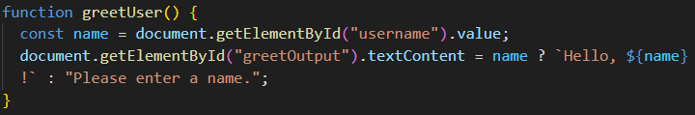
Task 3: Function with Return Value
Objective: To differentiate between a function that performs an action and a function that returns a value for further processing.
- Requirement: Create a mathematical "logic" function that calculates a square.
- Implementation: The square(num) function will return the product, which is then displayed by the handler function.
- Code:
// Function that calculates and RETURNS a value
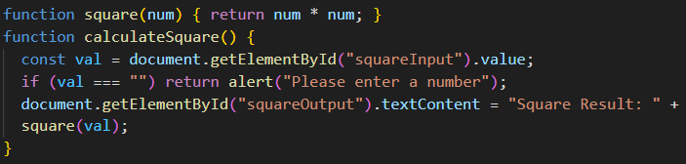
Task 4: Advanced Event Handling
Objective: To explore events beyond the standard mouse click.
- Requirement: Implement mouse tracking, state changes, and live keyboard feedback.
- Implementation:
  - Mouse Over/Out: Manipulate the .style.background property.
  - On Change: Update the document.body background based on a dropdown selection.
  - On Keyup: Synchronise input value with a paragraph text in real-time.
- Code:
// Mouse Events
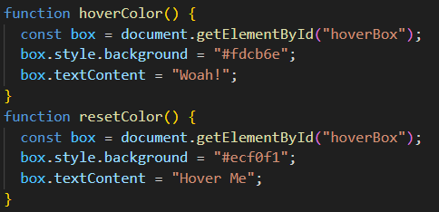
// Change Event (Themes)
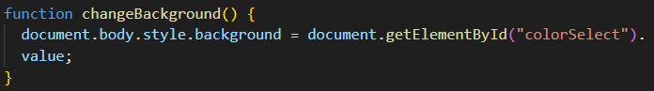
// Keyboard Event (Live Typing)
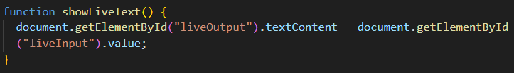

Part 3: Lab Exercises
Instructions: Now, apply everything you have learned to complete the Exercises section. You must write these functions yourself inside the <script> tag.
Exercise | Key Concept
Q1. Calculator | Use parseFloat() and backticks (` `) for the output.
Q2. Eligibility | Use a ternary operator (condition ? true : false).
Q3. DOM | Use .textContent to change paragraph text.
Q4. Image | Change the .src attribute of the image.
Q5. Table | Use a for loop and .innerHTML.

Q1. Reusable Function
Write a function that takes two numbers as input and displays their sum, difference, product, and division. Provide input boxes and a button to trigger it.

Q2. Voting Eligibility (with Functions)
Create a function checkEligibility(age) that checks if the user is eligible to vote (≥18). The result should be shown when the user enters their age and clicks a button.

Q3. Change Text on Button Click
Create a button that, when clicked, changes the text of a <p> element from "Before Click" to "After Click".

Q4. Image Hover Event
Display an image. When the mouse hovers, change it to another image; when it leaves, change it back.
Q5. Multiplication Table Generator
Create a function that generates a multiplication table for a number entered by the user (up to 10) and displays it inside a <div>.
Answer Key for Lab Exercises
JavaScript
// Q1: Calculator
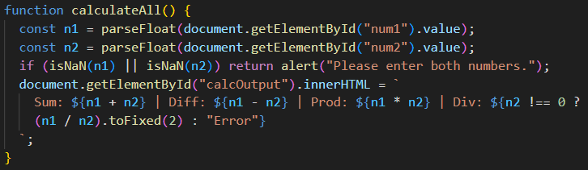
// Q2: Voting
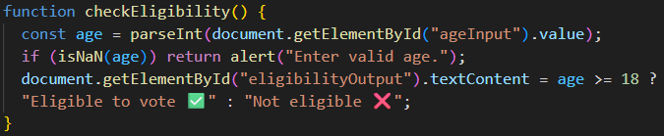
// Q3: Text Update
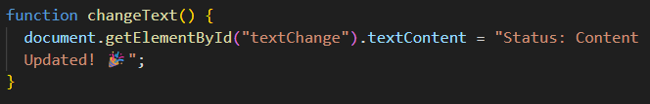
// Q4: Image Hover
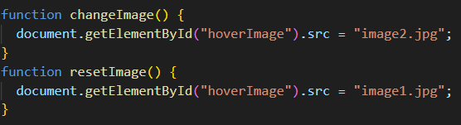
// Q5: Loops
